CourseGrades Mastery Assignment
Error log
Stefan S
CSE 2120 Data Structures 1
(CourseGrades.java)
Describe the errors you’ve encountered while working on this assignment. What caused the error and how do you overcome the error?
The errors I’ve encoutered while writing this program are too numerous to list indivudually. They almost exclusively involve my attempts to write to and from a CSV file.
Just to name a few:
- Logic Error: scanner.delimiter() returns the delimiter used by the scanner. scanner.useDelimiter(String) actually changes the delimiter.
- Syntax Error: I forgot how to properly write a try-catch loop, i wrote `try {} except() {}` which didn’t work because the proper syntax is `try{} catch(Exception ...) {}
- Runtime Error: I forced this one intentionally in order to test the above try-catch error handling, but I had to figure out Thow NullPointerException works in relation to reading files with the Scanner class.

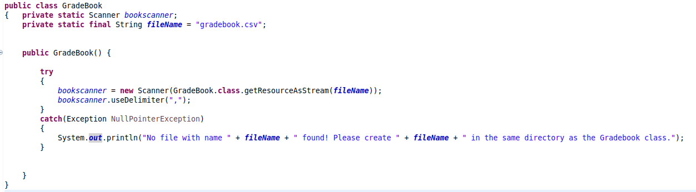
This was the first version of the GradeBook class which didn’t throw any errors. My first attempts involved importing java.io.File, which forced me to use the throws keyword, which caused issues when constructing a GradeBook object in CourseGrades.java (explicit vs implicit constructors? Constructor chaining? Far out of my depth.)

Logic Error:
When writing my first method for GradeBook, getStudents, I realized that a Scanner cannot be returned to the beginning of a file. This meant that I had to create a new method which would create a new Scanner for every time that a Scanner was needed.
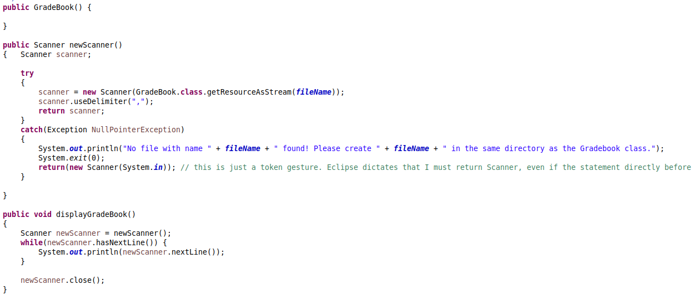
This screenshot shows both how I create Scanners in GradeBook.java, and how I use them. Thankfully this allows us to go through the CSV file as many times as we like
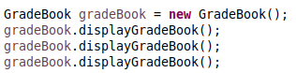
Logic error I noticed, as I was writing this error log: newScanner() is Public. It should be Private.

(apologies for the change in font, I’m using eclipse on my home computer) When trying to implement writing to the CSV file, I found out that you have to use the File class in order to point to the file to write to.
While (String, boolean) is technically a valid constructor for FileWriter, I get a FileNotFoundException after running this code.
For context, in my newScanner() method I use an InputStream object to point to the file:
So I’ll have to add yet another class to GradeBook.java

When trying to implement the File class, i did a quick test:
Creating a new File (object) and then asking for the directory returned the following:
As opposed to where gradebook.csv SHOULD be located, which is .../git/CS20P2F2024/chapter9/mastery/gradebook.csv
This behaviour is bizzare to me, but partially fixed by a simple “/src/mastery/” before fileName
Unfortunately, this means that my program is not portable. If I decide that I have the time, I’ll go back and fix this.

Also, and even more bizzarely, when I run addStudent(), the student isn’t added to gradebook.csv right away. I have to tab into gradebook.csv inside of Eclipse for the update to then register.
This is an Eclipse specific issue! It can be fixed by going to `Window > Prefrences > General > Workspace and click “Refresh using native hooks or polling”. It won’t poll instantly, but it’s better than never.
Eclipse also happens to have plugins for programatically refreshing files, but I’d rather not deal with IDE extensions, it’ll only complicate things.
For simplicity, I’ve added instructions to manually refresh files for Eclipse users in my output.

For whatever reason, this bit of code executed gradeBook.addStudent() immediately, rather than waiting for a user input first.
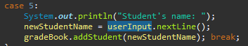
This doesn’t happen with userInput.next() .
For some God forsaken reason, running userInput.nextLine() directly afterwards newStudentName = userInput.nextLine();. I’m starting to get a feel for what spaghetti code is like.

Regular expressions were, as usual, difficult. It turns out that you need to use 2 escape characters (backslashes) rather than one in order to include square brackets within your regular expression.
I spent so long trying to figure out why this loop wouldn’t start. I don’t know how I ended up using an assignment operator instead of the equality operator.

